**Scientific Equipment and Apparatus**

1. How is an apparatus different to equipment?

**An apparatus is more than one piece of equipment used together to complete a task/experiment. Equipment is one piece of scientific instrument on its own.**

1. A student is using a Bunsen burner to heat some water in a beaker. Draw a labelled diagram of how the student should set up their equipment.

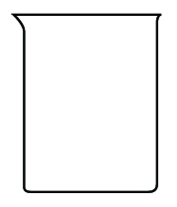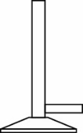

beaker

gauze mat

tripod

Bunsen burner

heatproof mat

1. A student is filtering a mixture of sand and water using a filter funnel and filter paper into a conical flask. Draw a labelled diagram of their equipment.

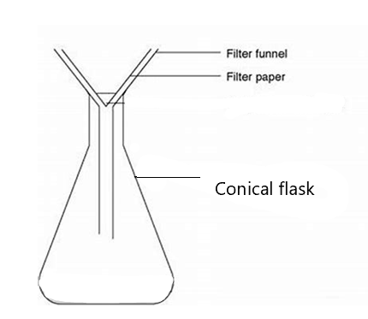

1. In the puzzle below, there are diagrams of ten different pieces of equipment. Can you find and name them? There are no heatproof mats or watch-gasses in the picture. 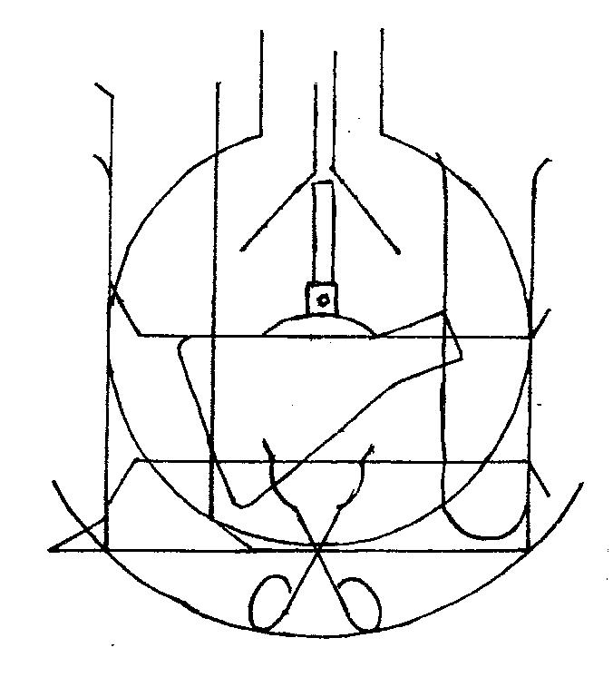

* **Bunsen burner**
* **Measuring cylinder**
* **Filter funnel**
* **Conical flask**
* **Test tube**
* **Evaporating basin**
* **Round bottom flask**
* **Test tube tongs**
* **beaker**

|  |  |  |  |  |  |  |  |  |  |  |  |  |  |  |
| --- | --- | --- | --- | --- | --- | --- | --- | --- | --- | --- | --- | --- | --- | --- |
| S | T | I | R | R | I | N | G | R | O | D | P | F | S | K |
| E | L | H | D | E | C | B | A | S | T | R | L | R | R | S |
| S | L | F | E | H | C | C | L | K | R | N | D | E | M | A |
| E | O | T | F | R | I | H | Y | D | E | M | C | N | I | L |
| S | R | E | T | I | M | L | D | L | H | E | K | R | C | F |
| S | L | S | O | D | R | O | U | S | I | P | L | U | C | L |
| A | P | T | S | T | N | L | M | F | U | N | E | B | F | A |
| L | L | T | R | P | O | R | K | E | G | O | D | N | O | C |
| G | A | U | Z | E | M | A | T | A | T | L | K | E | O | I |
| Y | H | B | T | G | K | D | S | F | T | E | T | S | R | N |
| T | H | E | I | A | K | A | O | C | G | D | R | N | P | O |
| E | F | G | D | S | P | O | E | W | Y | P | I | U | T | C |
| F | U | N | N | E | L | S | R | B | P | T | P | B | A | F |
| A | K | F | H | D | N | A | T | S | T | R | O | T | E | R |
| S | O | P | I | L | F | R | A | I | K | C | D | R | H | O |

1. Usually placed over a Bunsen burner (6) tripod
2. Measuring __________ (8) cylinder
3. Eye protection (6,7) safety glasses
4. Used for measuring temperature (11) thermometer
5. For scooping small amounts of chemicals (7) spatula
6. Sits on top of tripod (5,3) gauze mat
7. Can be used to heat large amounts of liquid (6) beaker
8. Used for heating objects (6,6) Bunsen Burner
9. Cone-shaped item (7,5) conical flask
10. Helps pour liquid into containers (6) funnel
11. Used to stir mixtures (8,3) stirring rod
12. Clamps are attached to this using a boss head (6,5) retort stand
13. For heating small amounts of liquids (4,4) test tube
14. A ___________ mat protects the bench (9) heatproof